Tableau Homework #16

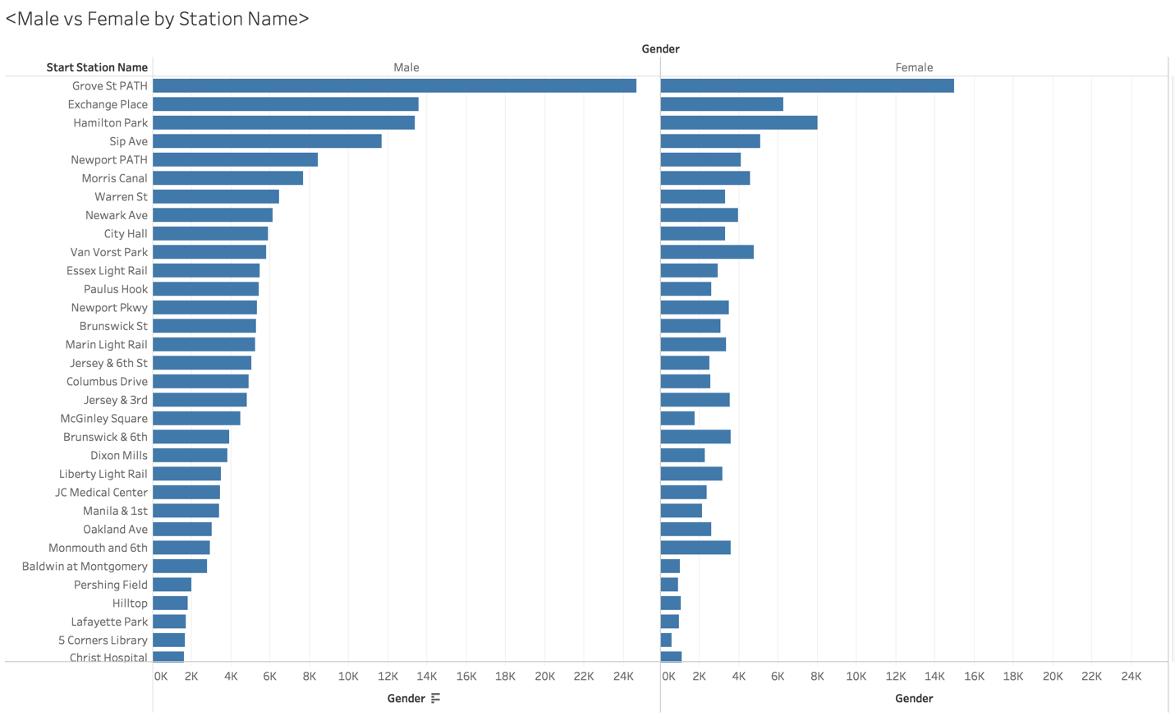

By the graph shown above we can infer that the number of costumers that ride bikes is bigger in the male population. Around 24k male costumers ride the bikes out of the Grove St PATH station vs 15k Women who ride bikes out of the same station. Grove St Path station is the most populated station compared to Christ hospital which only has around 2k costumer riding bikes out of that station.

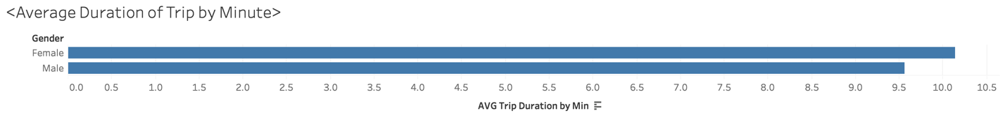

The image above reflects the difference in Avg total time riding bikes between female and male riders. As shown above we can see that male riders have and average time of 9.5min which is ½ a minute faster than the average trip for females as it is 10 min.



Female=Red

Men=Orange

The image above shows us the average trip duration by month from January through November. From the graph we can learn that during the months of April and May are the peak seasons that costumers prefer to go on rides. It could relate with the fact that during those months the season is considered Spring time and weather is more enjoyable.

For female riders the peak month is in May compared to the male peak season that is in the month of April. The peak duration time for women in the month of May is almost 13 min. the peak duration for men during the month of April is 12 min.

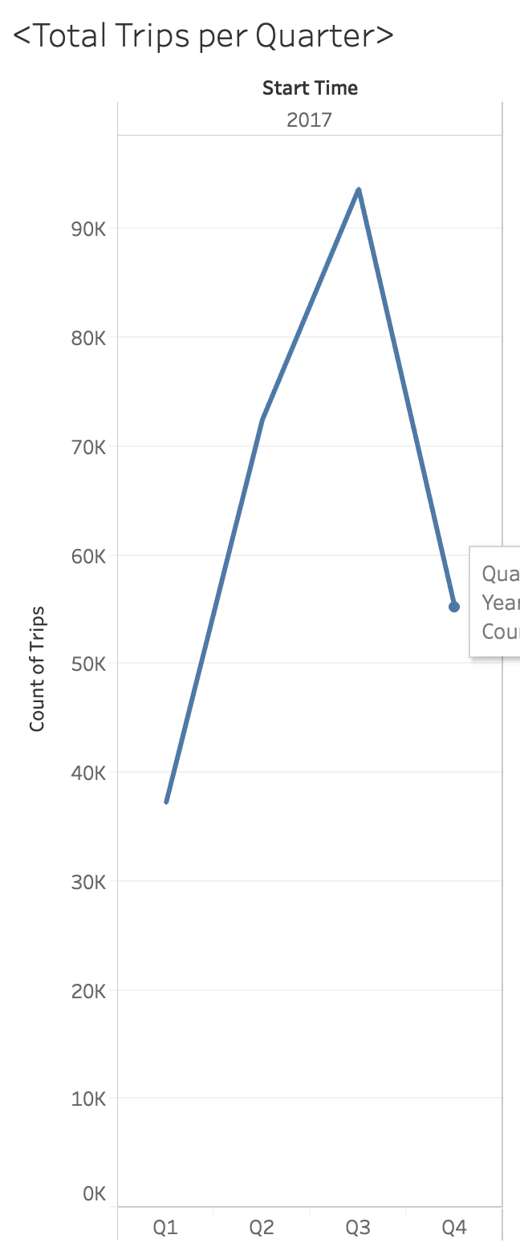

The graph above shows the total rides per business quarter. The peak number of rides was reached during Q3 with a total of around 90k bike rides. The lowest point was reached during Q1 with around 35-39k rides.